Задание 1
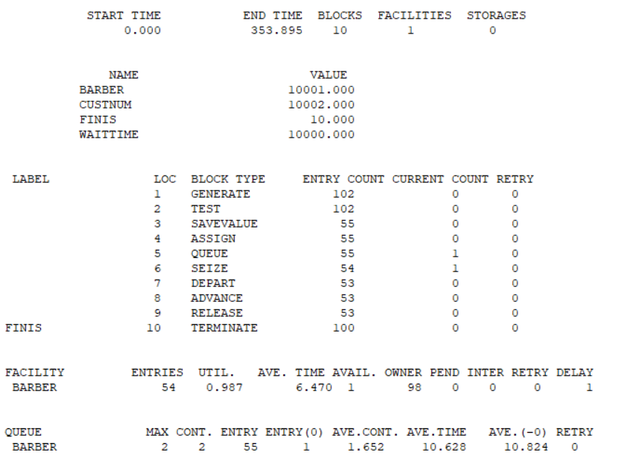

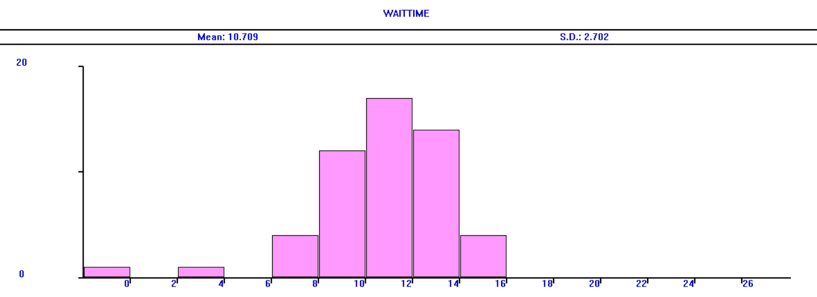
Результат работы и гистограмма Barber.gps
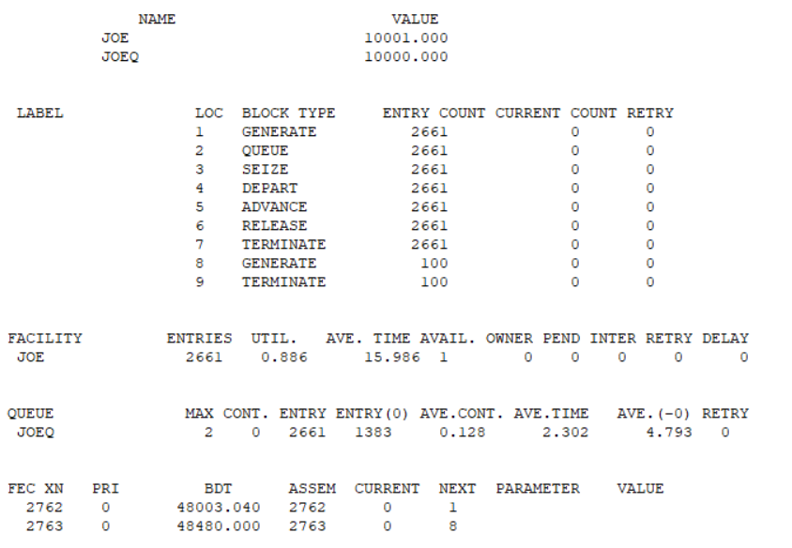
Результат работы Schr2a.gps
В результате мы видим, что прогон у barber сильно короче, чем у schr2a, первый был загружен 98,7% всего времени, а второй всего 88,6% времени. При этом среднее время в очереди у второй модели значительно меньше, а среднее время обслуживания – наоборот больше.
Задание 2
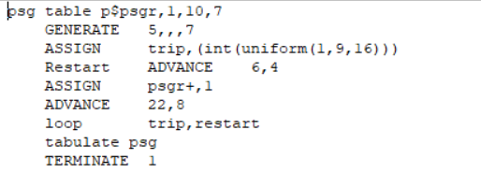
Код модели TaxiModel

Задание 3
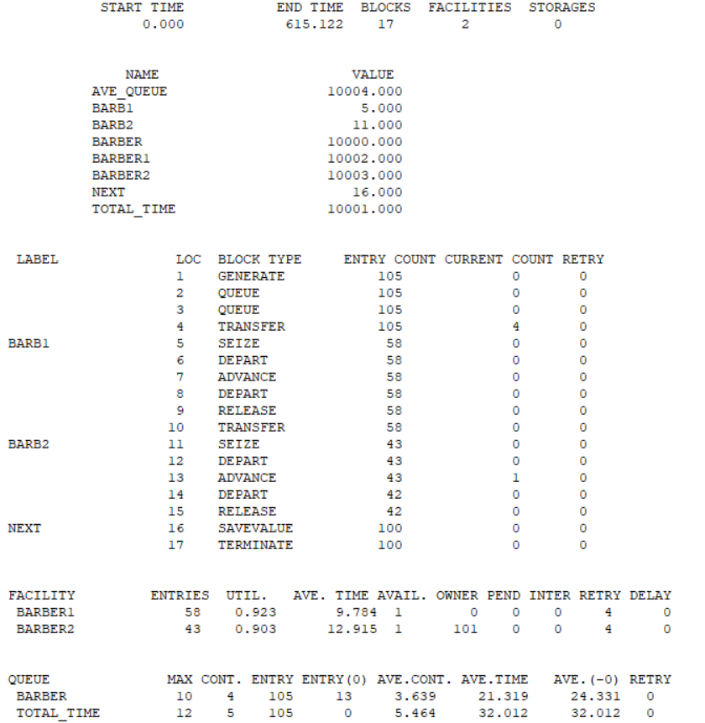
Результат работы Sampque.gps
Модель sampque является улучшенной версией barber, в которой работает два человека вместо одного. Вследствие этого загруженность каждого из работников меньше, но среднее время обслуживания стало больше в сравнении с barber. При этом очередь в sampque гораздо длительнее, чем у barber. Таким образом, эта модель, несмотря на наличие двух работников, работает хуже, чем модель с одним.
Код модели на Python:
import simpy
import random
import math

def exponential(mean):
return random.expovariate(1.0 / mean)

class GPSS_Blocks:
def __init__(self):
self.entry_count = {}
self.current_count = {}

def increment_entry(self, block_name):
self.entry_count[block_name] = self.entry_count.get(block_name, 0) + 1

def increment_current(self, block_name):
self.current_count[block_name] = self.current_count.get(block_name, 0) + 1

def decrement_current(self, block_name):
self.current_count[block_name] = max(0, self.current_count.get(block_name, 0) - 1)

def customer_process(env, customer_id, barber1, barber2, stats, blocks):
"""
1. GENERATE - создание клиента
2. QUEUE Barber - вход в очередь
3. QUEUE Total_time - вход в очередь
4. TRANSFER Both,Barb1,Barb2 - выбор свободного барбера
5. Barb1/Barb2 - SEIZE, DEPART, ADVANCE, DEPART, RELEASE
6. Next - SAVEVALUE, TERMINATE
"""

blocks.increment_entry("QUEUE_Barber")
blocks.increment_current("QUEUE_Barber")
queue_barber_start = env.now
stats['barber_queue'].append(env.now)

blocks.increment_entry("QUEUE_Total_time")
blocks.increment_current("QUEUE_Total_time")
total_time_start = env.now
stats['total_queue'].append(env.now)

blocks.increment_entry("TRANSFER")

available_barbers = []
if barber1.count == 0:
available_barbers.append(('barb1', barber1))
if barber2.count == 0:
available_barbers.append(('barb2', barber2))

if available_barbers:

chosen = available_barbers[0]
else:

chosen = random.choice([('barb1', barber1), ('barb2', barber2)])

chosen_name, chosen_barber = chosen
blocks.increment_entry(f"SEIZE_{chosen_name.upper()}")
with chosen_barber.request() as req:
yield req
blocks.increment_current(f"SEIZE_{chosen_name.upper()}")

blocks.increment_entry("DEPART_Barber")
queue_barber_end = env.now
barber_queue_time = queue_barber_end - queue_barber_start
stats['barber_queue'][-1] = barber_queue_time
blocks.decrement_current("QUEUE_Barber")

blocks.increment_entry("ADVANCE")
if chosen_name == 'barb1':

service_time = random.normalvariate(10, 2.5)

service_time = max(0.1, service_time)
stats['barber1_usage'] += 1
stats['barber1_time'] += service_time
else:

service_time = random.normalvariate(13, 4)
service_time = max(0.1, service_time)
stats['barber2_usage'] += 1
stats['barber2_time'] += service_time

yield env.timeout(service_time)

blocks.increment_entry("DEPART_Total_time")
total_time_end = env.now
total_system_time = total_time_end - total_time_start
stats['total_queue'][-1] = total_system_time
blocks.decrement_current("QUEUE_Total_time")

blocks.increment_entry(f"RELEASE_{chosen_name.upper()}")
blocks.decrement_current(f"SEIZE_{chosen_name.upper()}")

blocks.increment_entry("SAVEVALUE")
if stats['barber_queue']:
avg_queue = sum(stats['barber_queue']) / len(stats['barber_queue'])
stats['ave_queue'] = avg_queue

blocks.increment_entry("TERMINATE")
stats['terminated'] += 1

def customer_generator(env, barber1, barber2, stats, blocks, max_customers=105):
"""Блок 1: GENERATE (Exponential(1,0,6.5))"""
customers_created = 0
while customers_created < max_customers:

interarrival_time = exponential(6.5)
yield env.timeout(interarrival_time)

blocks.increment_entry("GENERATE")
customers_created += 1
stats['generated'] = customers_created

env.process(customer_process(env, customers_created, barber1, barber2, stats, blocks))

def run_simulation(runtime=615.122, max_customers=105):

env = simpy.Environment()

barber1 = simpy.Resource(env, capacity=1)
barber2 = simpy.Resource(env, capacity=1)

stats = {
'generated': 0,
'terminated': 0,
'barber_queue': [], # Время в очереди Barber
'total_queue': [], # Общее время в системе
'barber1_usage': 0,
'barber2_usage': 0,
'barber1_time': 0,
'barber2_time': 0,
'ave_queue': 0
}

blocks = GPSS_Blocks()

env.process(customer_generator(env, barber1, barber2, stats, blocks, max_customers))

env.run(until=runtime)

print_report(env, stats, blocks, runtime, max_customers)

def print_report(env, stats, blocks, runtime, max_customers):
print("\n" + " " * 18 + "GPSS World Simulation Report - Sampque.1.1 (Python/SimPy)")
print(" " * 16 + "=" * 60)
print(f"\n START TIME END TIME BLOCKS FACILITIES STORAGES")
print(f" {0.000:10.3f} {env.now:10.3f} 17 2 0\n")

print("\n LABEL LOC BLOCK TYPE ENTRY COUNT CURRENT COUNT RETRY")
blocks_list = [
("", 1, "GENERATE", stats['generated'], 0),
("", 2, "QUEUE", blocks.entry_count.get("QUEUE_Barber", 0),
blocks.current_count.get("QUEUE_Barber", 0)),
("", 3, "QUEUE", blocks.entry_count.get("QUEUE_Total_time", 0),
blocks.current_count.get("QUEUE_Total_time", 0)),
("", 4, "TRANSFER", blocks.entry_count.get("TRANSFER", 0), 0),
("BARB1", 5, "SEIZE", blocks.entry_count.get("SEIZE_BARB1", 0),
blocks.current_count.get("SEIZE_BARB1", 0)),
("", 6, "DEPART", blocks.entry_count.get("DEPART_Barber", 0), 0),
("", 7, "ADVANCE", blocks.entry_count.get("ADVANCE", 0) // 2, 0), # Примерно
("", 8, "DEPART", blocks.entry_count.get("DEPART_Total_time", 0), 0),
("", 9, "RELEASE", blocks.entry_count.get("RELEASE_BARB1", 0), 0),
("", 10, "TRANSFER", blocks.entry_count.get("TRANSFER", 0) // 2, 0),
("BARB2", 11, "SEIZE", blocks.entry_count.get("SEIZE_BARB2", 0),
blocks.current_count.get("SEIZE_BARB2", 0)),
("", 12, "DEPART", blocks.entry_count.get("DEPART_Barber", 0), 0),
("", 13, "ADVANCE", blocks.entry_count.get("ADVANCE", 0) // 2, 0),
("", 14, "DEPART", blocks.entry_count.get("DEPART_Total_time", 0), 0),
("", 15, "RELEASE", blocks.entry_count.get("RELEASE_BARB2", 0), 0),
("NEXT", 16, "SAVEVALUE", blocks.entry_count.get("SAVEVALUE", 0), 0),
("FINIS", 17, "TERMINATE", stats['terminated'], 0)
]

for label, loc, btype, entry, current in blocks_list:
print(f" {label:6} {loc:3} {btype:10} {entry:12} {current:12} 0")

print("\n\nFACILITY ENTRIES UTIL. AVE. TIME AVAIL. OWNER PEND INTER RETRY DELAY")
if stats['barber1_usage'] > 0:
util1 = stats['barber1_time'] / env.now
avg_time1 = stats['barber1_time'] / stats['barber1_usage']
print(f" BARBER1 {stats['barber1_usage']:3} {util1:.3f} {avg_time1:8.3f} 1 0 0 0 0 0")
if stats['barber2_usage'] > 0:
util2 = stats['barber2_time'] / env.now
avg_time2 = stats['barber2_time'] / stats['barber2_usage']
print(f" BARBER2 {stats['barber2_usage']:3} {util2:.3f} {avg_time2:8.3f} 1 0 0 0 0 0")

print("\n\nQUEUE MAX CONT. ENTRY ENTRY(0) AVE.CONT. AVE.TIME AVE.(-0) RETRY")

if stats['barber_queue']:
max_barber = max(stats['barber_queue']) if stats['barber_queue'] else 0
entry_barber = len(stats['barber_queue'])
entry0_barber = sum(1 for t in stats['barber_queue'] if t < 0.001)
avg_cont_barber = sum(stats['barber_queue']) / env.now if env.now > 0 else 0
avg_time_barber = sum(stats['barber_queue']) / entry_barber if entry_barber > 0 else 0
avg_time_no0 = sum(t for t in stats['barber_queue'] if t >= 0.001) / max(1, entry_barber - entry0_barber)
print(f" BARBER {max_barber:3.0f} {entry_barber:5} {entry0_barber:3} {avg_cont_barber:7.3f} {avg_time_barber:7.3f} {avg_time_no0:8.3f} 0")

if stats['total_queue']:
max_total = max(stats['total_queue']) if stats['total_queue'] else 0
entry_total = len(stats['total_queue'])
entry0_total = sum(1 for t in stats['total_queue'] if t < 0.001)
avg_cont_total = sum(stats['total_queue']) / env.now if env.now > 0 else 0
avg_time_total = sum(stats['total_queue']) / entry_total if entry_total > 0 else 0
print(f" TOTAL_TIME {max_total:3.0f} {entry_total:5} {entry0_total:3} {avg_cont_total:7.3f} {avg_time_total:7.3f} {avg_time_total:8.3f} 0")

print("\n\nSAVEVALUE RETRY VALUE")
print(f" AVE_QUEUE 0 {stats['ave_queue']:.3f}")

print("\n\nCEC XN PRI M1 ASSEM CURRENT NEXT PARAMETER VALUE")

print(" - - - - - - - -")

print("\n\nFEC XN PRI BDT ASSEM CURRENT NEXT PARAMETER VALUE")
print(f" 1 0 {env.now+100:.3f} 1 0 1")

print("\n" + "=" * 80)

if __name__ == "__main__":
random.seed(42) # Для воспроизводимости
run_simulation(runtime=615.122, max_customers=105)

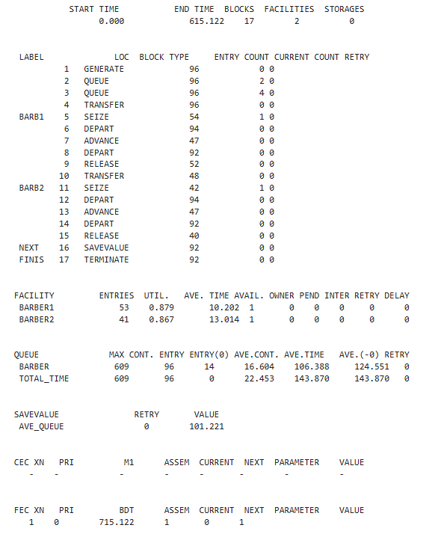
Результат работы sampque.py
Модель в Python получилась менее нагруженной, но время ожидания выросло в разы, то есть модель показывает худшие результаты, чем изначальная, несмотря на наличие двух барберов.

